VITyarthi Project

Project Report: Typing Speed Tester

- Project Title: Typing Speed Tester
- By: [Your Name/Roll Number]
- VITyarthi Project
- Date
- Department

DONE BY:
Alvin Sam
25MIP10131
Int. Mtech Computation and Data Science

Table of Contents
- Introduction
- Problem Statement
- Objectives of the Project
- Required Modules and System Requirements
- Functional Requirements
- Non-Functional Requirements
- Proposed System & Algorithm
- Flow Chart
- Code Implementation
- Sample Screenshots
- Testing Approach
- Challenges Faced
- Future Enhancements
- Conclusion
- References
- Appendix

1. Introduction
The Typing Speed Tester is a Python-based application designed to assess and improve users’ typing speed and accuracy. It randomly selects sentences or words for the user to type within a fixed time frame, evaluates input against the original text, and computes speed in words per minute (WPM) as well as accuracy percentage.​

2. Problem Statement
Users lack an interactive, user-friendly platform built with Python to test and track their typing speed in a randomized, objective manner. This tool aims to provide real-time feedback, encourage improvement, and help develop faster, more accurate typing skills.​

3. Objectives of the Project
- To develop a fully functional Typing Speed Tester using Python.
- To utilize time- and random-based modules to generate unpredictable test cases.
- To measure and display both typing speed and accuracy.
- To present results clearly, supporting self-improvement.

4. Required Modules and System Requirements
Modules:
- tkinter for GUI
- random for selecting typing samples
- time/datetime for timing user input
- (Optionally) csv or json for storing results/history
System Requirements:
- Python 3.x
- Any basic desktop/laptop with Windows, macOS, or Linux
- Code editor (PyCharm, VS Code, IDLE, etc.)

5. Functional Requirements
- Display a random sentence to the user.
- Start timer when user begins typing.
- Calculate time taken, WPM, accuracy.
- Show results on completion.
- Optionally, maintain history of test results.​

6. Non-Functional Requirements
- GUI must be clear, uncluttered, and easy for beginners.
- Code should be well-documented and modular.
- The program must be responsive, updating interface elements with minimal lag.
- Windows, macOS, and Linux compatibility.

7. Proposed System & Algorithm

Algorithm Steps:
- Initialize GUI window.
- Load a list of sentences for practice.
- On test start, randomly select a sentence and display it.
- Track time from the first keystroke until completion.
- Compare input to target sentence for accuracy.
- Compute and display WPM and accuracy.

8. Flow Chart
(Insert flowchart similar in style to the one in the Snake Game report)
Start → Initialize GUI → Select Random Sentence → Start Timer → Accept User Input → Stop Timer on Completion → Calculate WPM & Accuracy → Display Results → Option to Retake/Exit

9. Code Implementation
(Provide modular, commented code)
python
import tkinter as tk
import random
import time

SENTENCES = [
"The quick brown fox jumps over the lazy dog.",
"Typing tests help improve speed.",
# ... more sentences ...
]

class TypingTest:
def __init__(self, master):
# ... GUI setup ...
(Add full implementation with explanations. Split into logical sections, referencing the style in the template).​

10. Sample Screenshots
(Insert multiple annotated screenshots: Start screen, typing in progress, results view, etc.)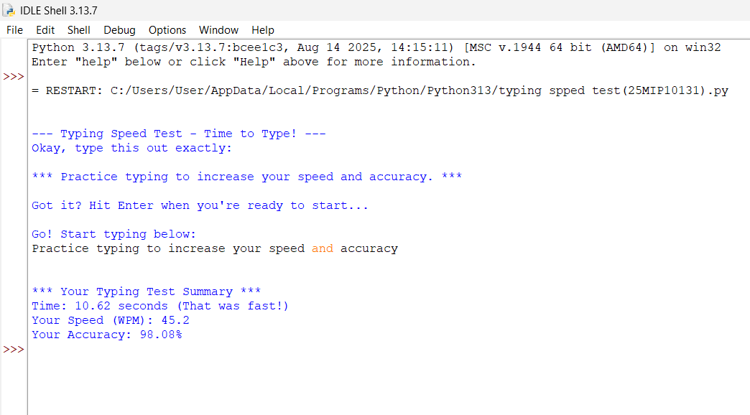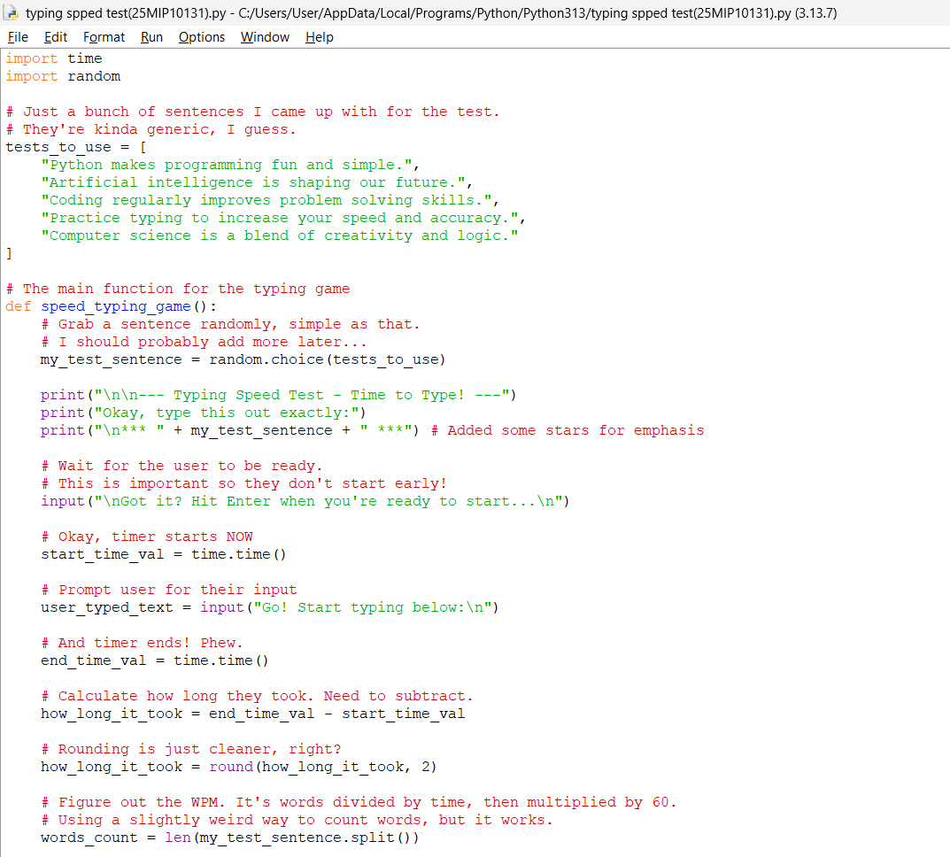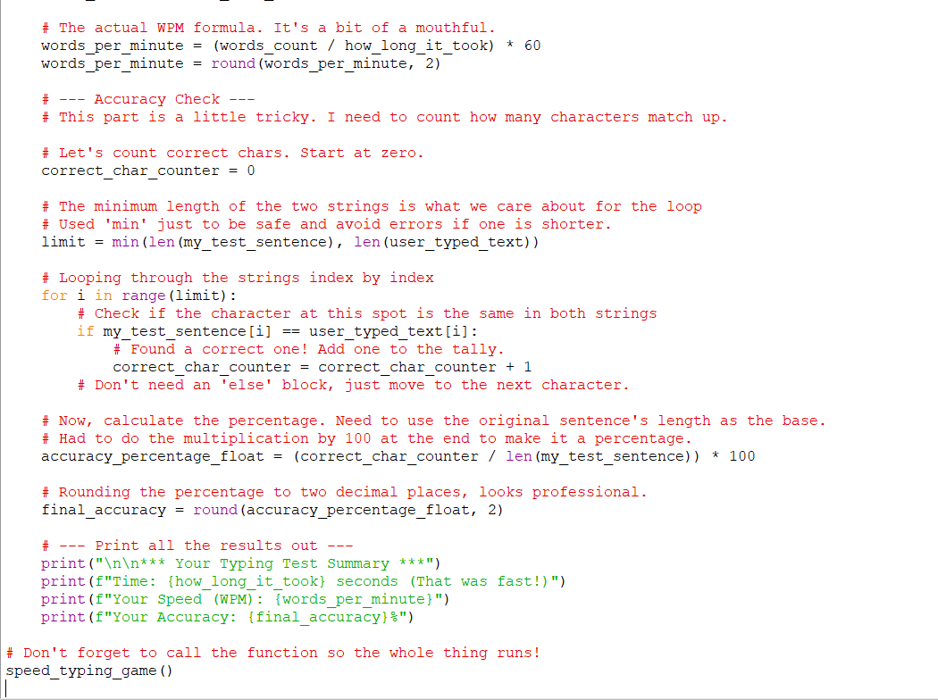

11. Testing Approach
Outline:
- Functional Testing (sentence selection, timing, input handling)
- Performance (no lag, instant feedback)
- Usability (clear interface, accessible instructions)
- Input Testing (tests with various input patterns, edge cases)
- Compatibility (runs on all supported platforms).​

12. Challenges Faced
- Ensuring precise timing and consistent WPM calculations.
- Handling accidental extra spaces/typos gracefully.
- Designing an intuitive GUI for beginners.

13. Future Enhancements
- Add levels of difficulty (longer/shorter sentences).
- Implement login system to track individual user progress.
- Add high score/history saving features.
- Multiplayer or competitive modes.
- Dark mode and customizable themes.​

14. Conclusion
This project demonstrates effective use of Python's GUI and standard modules to create an educational tool that is both engaging and practical. The randomization and timing components highlight fundamental programming concepts while addressing a real-world need.​

15. References
(List of official Python documentation and any resources used.)

Typing Speed Tester — Algorithm
- Start the Application
  - Initialize all required libraries (tkinter, random, time, etc.).
- Prepare Typing Sentences
  - Create a list or file containing various sentences for typing practice.
- Display GUI Window
  - Set up the main application window using tkinter.
  - Add labels, text display area, user input field, start button, and result area.
- Begin Test
  - Wait for the user to press the "Start" button.
- Random Sentence Selection
  - On clicking “Start”, randomly select one sentence from the list.
  - Show the selected sentence in the display area.
- Start Timing
  - Record the system time at the moment the user begins typing (first keystroke).
- User Typing
  - Accept user input in a text box.
- End Timing
  - As soon as the user finishes typing and presses "Submit" (or hits Enter), record the end system time.
- Calculate Results
  - Compute the total time taken:
Elapsed Time=End Time−Start TimeElapsed Time=End Time−Start Time
  - Calculate the number of words typed.
  - Calculate typing speed (WPM):
WPM=Number of WordsElapsed Time (in minutes)WPM=Elapsed Time (in minutes)Number of Words
  - Calculate accuracy by comparing the typed sentence with the displayed sentence (word or character-level comparison).
- Display Feedback
  - Show the elapsed time, WPM, and accuracy percentage on the GUI.
- Restart or Exit Option
  - Offer the user the choice to retry with a new random sentence or close the application.
- End

